

NAS With Raspberry Pi

Submitted by: Lester Voon & Diarmaid Walsh

Student number: R00158181 & R00160174

Supervisor: Manuel Caballero

Assessor: Manuel Caballero

Department of Electrical & Electronic Engineering

Table of Contents

List of Figures ii

Declaration iii

1 Summary 1

1.1 Abstract 1

1.2 Objective 1

1.3 Review of State of The Art 2

1.4 Ethical Issues 3

1.5 Standards and regulations 3

2 Design Specification 4

3 Design of the System 5

3.1 Solution 5

3.2 Comparisons 5

4 Implementation 6

4.1 Basic Tests 6

4.2 Main Tests 6

5 Results 7

6 Cost 7

7 Conclusion 8

8 Annex 9

8.1.1 References 9

8.1.2 Calculations 9

8.1.3 Source code 9

8.1.4 Raspberry Pi 3 Model B+ Datasheet Link 10

# List of Figures

Figure 1: Design of the System 5

Figure 2: Raspberry Pi NAS remote access VPN map (Crawford) 8

# 

# Declaration

I declare that my submission is my own work and writing.

Any text, diagrams or other material copied from other sources (including, but not limited to, books, journals and the internet) have been clearly acknowledged and referenced as such in the text by the use of ‘quotation marks’ (or indented italics for longer quotations) followed by the author’s name and date [e.g. (Byrne, 2008)] either in the text or in a footnote/endnote. These details are then confirmed by a fuller reference in the bibliography section.

I acknowledge that I understand the concept of plagiarism. I have studied CIT’s guide to referencing (Section 3 Referencing at <http://www.mycit.ie/libraryguide/>) and I have read the section on Plagiarism and Cheating (pages 46 – 49) in CIT’s Student Regulations handbook (available at http://www.mycit.ie/ ). I understand that only assignments which are free of plagiarism will be awarded marks. By submitting this assignment I agree to these terms. I further understand that CIT has a plagiarism policy which can lead to the suspension or permanent expulsion of students in serious cases.

I understand that my project report will be evaluated by the SafeAssignment/TurnItIn tool in Blackboard to detect instances of plagiarism.

Signed: _____________________________

Date: __________________

# Summary

## Abstract

The following project was done to create a low powered NAS at home with a Raspberry Pi 3 and hard drives. The Raspberry Pi was first set up and configured so that the drive could be access anywhere at home through WIFI or ethernet. The NAS was set up through the terminal in Raspbian.

## Objective

To create a low-powered NAS at home which allows files to be accessed anywhere at home through WIFI or ethernet. This is done as obtaining files from different computer is very troublesome. Thus, saving files on the NAS would allow files to be easily accessible.

## Review of State of The Art

A NAS is a file-level computer data storage server connected to a network providing access to several computers1 (Wikipedia, 2019). To have the Raspberry Pi working properly, the OS was initially updated. Then, the Samba package required for the NAS to work on the Raspberry Pi was installed on the device. For the NAS to work, the configuration file of the Samba Server has to be changed. Then, on the PC, the ‘map network drive’ was used to link the NAS with the PC by using the IP address of the Raspberry Pi. The SD card of the Raspberry Pi is initially used to check if the NAS server is working properly. If it is, an external drive was then connected to the Raspberry Pi. The hard disk was then mounted on the Pi. This is done by installing ntfs-3g package which allows ntfs drives to be used with the Pi. The config files has to be updated again for the external drive to work. Then, the ‘map network drive’ was used again to allow access to the external hard disk. The samba server will then be restarted2 (Raspberry Pi NAS ultimate guide, n.d.).

To access the NAS remotely it will be connected to a VPN server. The virtual IP address in the dynamic IP address fields was specified. This is done by enabling the PPTP VPN server. Then, the OpenVPN server is enabled and the dynamic IP address was specified. The L2TP/IPSec was then enabled. A Dynamic IP address will then be specified to the following3 (megamorf, 2015),

## Ethical Issues

There are no ethical issues in this project.

## Standards and regulations

There are no standards and regulations.

# Design Specification

The project uses a Raspberry Pi 3 Model B+ with the CPU of ARM Cortex-A53 which has a base speed of 1.4GHz. The Pi has a SRAM of 1GB. The device has Wi-Fi of 2.4GHz and 5GHz. The Ethernet speed on the Raspberry Pi 3 B+ is 300Mbps. The current technology of Bluetooth the device uses is 4.2. The Raspberry Pi also contains 4x USB 2.0. The NAS system requires an external drive which will be connected to the Raspberry Pi’s USB. The external hard disk has a form factor of 2.5 Inch. The size of storage of the hard drive is 1TB.

# Design of the System

## Solution

The NAS system is created by having the Raspberry Pi connecting to a 1 TB hard drive as shown in the block diagram in Figure 1. The Raspberry Pi 3 B+ will then be connected to the internet via ethernet/ Wi-Fi depending on the convenience. The NAS will be accessed through the IP Address of the Raspberry Pi on other devices.

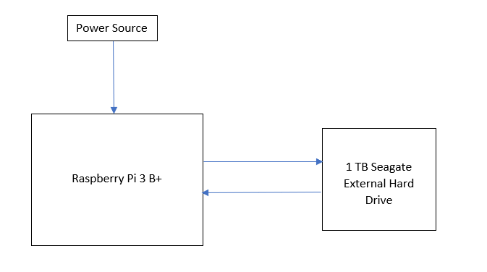

Figure 1: Design of the System

## Comparisons

Th NAS system can also be created with different storage devices such as a USB. However, the USB must be formatted and configured differently if it is to be used for this purpose.

Another alternative was to use a hard drive provided to us instead of buying one from the internet. The hard drive requires a case which would have to be bought online. The form factor of the hard drive is 3.5 inch and a case for this size drive is expensive. The Hard drive is also only 500 GB.

# Implementation

To implement this project, a few tests has to be done to ensure the NAS is working properly.

## Basic Tests

A USB stick was used for the basic test to ensure that the NAS was working. This was done by mounting the USB stick to a folder on the USB stick called EXTERNAL. After mounting, the EXTERNAL folder on the NAS was connected to PC. This was verified that it was working by creating a file on Raspbian and then checking it on Windows. After ensuring that it was working, the USB stick was unmounted.

## Main Tests

The external hard drive was connected to the Raspberry Pi and mounted into the folder created previously called EXTERNAL. The IP address of the Raspberry Pi was then entered on the Windows computer. Then, a file was created on Raspbian and then checked if it is working on Windows. Thus, the NAS was successfully created.

# Results

A file was created on the hard drive. Files were copy through and from the hard drive and it was working properly. Thus, a NAS was successfully implemented on the Raspberry Pi.

# Cost

|  |  |  |  |  |
| --- | --- | --- | --- | --- |
| **No.** | **Qty.** | **Description** | **Price** | **Comments** |
| 1 | 1 | Raspberry Pi 3 Model B+ Starter Pack | €60.00 | Provided by the college |
| 2 | 1 | External Hard Drive | €50.00 | Shared among group members |
| Total |  |  | €110.00 |  |

# Conclusion

A NAS can be created with a Raspberry Pi 3 at a low cost of €110 instead of spending €200 without the hard drive on a Synology. Apart from that, the Raspberry Pi NAS would be cheaper in the long run than a regular NAS as the Raspberry Pi 3 uses very little power. The Raspberry Pi NAS for this project was successful. To remotely connect to the Raspberry Pi NAS, a VPN can be used to virtually connect to the internet the NAS is connected to. This could not be implemented as a VPN would cost extra money for the project and we did not had the budget to do so as a student. The VPN connection map for a NAS is shown below.

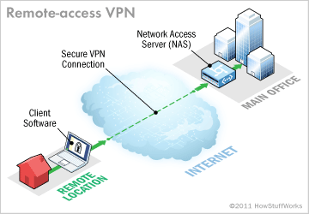

Figure 2: Raspberry Pi NAS remote access VPN map (Crawford)

# Annex

### References

Crawford, J. T. (n.d.). *How VPNs Work.* Retrieved from howstuffworks: https://computer.howstuffworks.com/vpn3.htm

megamorf. (2015, June). *How to securely access Home NAS*. Retrieved from superuser: https://superuser.com/questions/927030/how-to-securely-access-home-nas-from-wan

*Raspberry Pi NAS ultimate guide*. (n.d.). Retrieved from ELTECHS: https://eltechs.com/raspberry-pi-nas-guide/

Wikipedia. (2019, February 26). *Network-attached storage*. Retrieved from Wikipedia: https://en.wikipedia.org/wiki/Network-attached_storage

### Calculations

No calculations were needed

### Source code

Sudo apt-get update ;updates raspberry pi’s packages

sudo apt-get install samba samba-common-bin ;install Samba packages

sudo leafpad /etc/samba/smb.conf ;to change Samba configurations

sudo smbpasswd -a pi ;set a password for the NAS

sudo /etc/init.d/samba restart ;restarts the Samba server

/sudo apt-get install ntfs-3g ;to allow the Raspberry Pi to read ntfs drives

Sudo mkdir /EXTERNAL ;creating an external folder to be accessed

Sudo umount /media/pi/Drive ;unmount the drive’s original location

sudo mount /dev/sda1 /EXTERNAL ;mounts external drive to EXTERNAL folder

### Raspberry Pi 3 Model B+ Datasheet Link

<https://static.raspberrypi.org/files/product-briefs/Raspberry-Pi-Model-Bplus-Product-Brief.pdf>

Signed: _____________________________

Date: __________________